# **REPORT**

**EXPERIMENT 2: pH AND BUFFERS**

Group: 3 Class: IELS22IU41 Date: 11/1/2023

Group members:

|  | Full name | Student ID | Declaration of Contribution | Signature |
| --- | --- | --- | --- | --- |
| 1 | Phan Minh Ẩn | ITITSB22028 | pH of SALTS |  |
| 2 | Nguyễn Thành Trí | IELSIU22112 | Material and Method. Introduction |  |
| 3 | Đỗ Minh Duy | ITITSB22029 | Buffers |  |
| 4 | Nguyễn Phan Tuấn Anh | BTFTIU22164 | pH of STRONG ACID. pH of WEAK ACID |  |
| 5 | Nguyễn Quốc Tuấn | ITITIU22177 | pH of DEIONIZED WATER |  |

Total score: _______/100

**Part 1. Introduction**

According to the Arrhenius theory. a base is a chemical that dissociates in water to generate hydroxide (OH-) ions. while an acid is a molecule that dissociates in water into the hydronium ion (H3O+). According to the Lewis-Brnsted theory. an acid takes electrons away while a base gets them. A base receives a proton from water to produce OH- (a hydroxide ion) in an aqueous solution. while an acid's H+ connects with water to form H3O+ (a hydronium ion). In water. strong acids and bases completely breakdown into their corresponding hydronium ions (H3O+) and hydroxide ions (OH-). In an aqueous solution. weak acid/base only partially dissociates and produces little to no H3O+/OH-.

**Part 2. Materials and Methods**

**Materials:**

*- Lab equipment: Beaker. Cylinder. Stirring rod. Pipette. Volumetric flask*

*- Materials: 0.1M HCl. 0.1M NaOH. 0.01M NaOH. H2O. 0.1M CH3COOH. 0.01M CH3COOH. 0.001M CH3COOH. 0.1M NaCl. 0.1M CH3COONa. 0.1M NH4Cl. deionized water*

**Methods:**

* **pH OF DEIONIZED WATER**

step 1: pouring 50ml distilled water into the beaker by the cylinder

step 2: using stirring rod to stir in 20 seconds

step 3: stop stirring and record the pH

step 4: repeat step 2 and 3. with two times

step 5: doing the same procedure of step 2 and 3 until there is no significant change in pH value

* **pH OF STRONG ACID**
* With section 1: Preparation

step 1: taking nearly 10ml of 0.1M HCl into beaker 1

step 2: taking nearly 20ml of 0.1M NaOH into beaker 2

step 3: prepare 100ml of 0.01M NaOH solution

* With section 2: pH measurement

step 1: add 10ml of 0.1M HCl into the beaker and record pH

step 2: add 90ml distilled water and record pH

step 3: add 10ml of 0.1MNaOH into the beaker and record pH

step 4: add 90ml of 0.01 NaOH and record pH

step 5: Record the result respectively.

* **pH OF WEAK ACID**
* With section 1: Preparation

step 1: add 20ml of 0.1M CH3COOH into the beaker 1 and record pH

step 2: calculate the amount of each reactant to satisfy the dilute solution

step 3: take 2ml of beaker 1, and add into beaker 2, then add 18ml of distilled water. Record pH

step 4: take 2ml of beaker 2, and add into beaker 3, then add 18ml of distilled water. Record pH

step 5: record 3 results of pH

* With section 2: pH measurement

step 1: add 20ml of 0.1M CH3COOH into the beaker 1 and record pH

step 2: calculate the amount of each reactant to satisfy the dilute solution

step 3: take 2ml of beaker 1, and add into beaker 2, then add 18ml of distilled water. Record pH

step 4: take 2ml of beaker 2, and add into beaker 3, then add 18ml of distilled water. Record pH

step 5: record 3 results of pH

* **pH OF SALTS**
* With section 1: Preparation

step 1: add 20ml of 0.1M NaCl into beaker 1, then labeling it A

step 2: add 20ml of 0.1M CH3COONa into beaker 2, then labeling it B

step 3: add 20ml of 0.1M NH4Cl into beaker 3, then labeling it C

* With section 2: pH measurement

step 1: record pH of solution A

step 2: record pH of solution B

step 3: record pH of solution C

step 4: record the result.

* **pH OF BUFFERS**
* With section 1: Preparation

step 1: take 50ml of 0.1M CH3COOH

step 2: take 50ml of 0.1M CH3COONa

step 3: take 40ml of 0.1M HCl

step 4: take 40ml of 0.1M NaOH

* With section 2: Buffer A

step 1: add 10ml of 0.1M CH3COOH and 40ml of 0.1 CH3COONa into beaker 1; called Buffer A

step 2: record pH 2 twice, the second time after 5 mins from the first one.

step 3: divide equally into two separated beaker 1 and 2, then labeling Buffer A1 and Buffer A2 respectively.

step 4: record pH of each Buffer A1 and A2

step 5: add 10 drops of 0.1M HCl into the buffer A1 and record pH

step 6: add more drops of 0.1M HCl until the pH change from the start.

step 7: add 10 drops of 0.1M NaOH into the buffer A2 and record pH

step 8: add more drops of 0.1M NaOH until the pH change from the start.

**Part 3. Results and Discussion**

**1. pH OF DEIONIZED WATER**

| **Time**  **(second)** | **Observed pH** | | **Discussion** |
| --- | --- | --- | --- |
| **1st**  (Group___) | **2nd**  (Group___) |
| **0** |  |  | the pH increased slightly after stirring for a amount of time |
| **20** | 7.4 | 8.76 |
| **40** | 8.46 | 8.95 |
| **60** | 8.51 | 8.88 |

**2. pH OF STRONG ACID**

| **Solution** | **Theoretical pH** | **Measured pH** | | **Discussion** |
| --- | --- | --- | --- | --- |
| **1st**  (Group___) | **2nd**  (Group____) |
| **10 mL of 0.1M HCl** | 1 | 2.24 | 1.39 | the pH increased from the smallest amount to the highest amount. In contrast. there are many differences between Group 1and Group **2** |
| **Add 90 mL of distilled water** | 2 | 2.84 | 2.29 |
| **Add 10 mL of**  **0.1M NaOH** | 7 | 4.02 | 6.32 |
| **Add 90 mL of**  **0.01M NaOH** | 11.65 | 9.32 | 12.8 |

**Calculation:**

-The pH of 10ml of 0.1M HCl is: pH = -log(0.1) = 1

-The pH of 10ml of 0.01M HCl is: pH = -log(0.01) = 2

-After adding 10ml of NaOH. the solution is neutral because NaOH gave ion OH- to neutralize ion H+

So the pH=7

-[OH-]=(concentration of OH-)(the volume of OH-)/(total volume)

=0.01*(90*10-3)/(200*10-3)= 4.5*10-3

pOH = -log[4.5*10-3]=2.35 => pH= 14-2.35=11.65

**3. pH OF WEAK ACID**

| **Solution** | **Measured pH** | | **Ka** | **Discussion** |
| --- | --- | --- | --- | --- |
| **1st**  (Group___) | **2nd**  (Group____) |
| **0.1M acetic acid** | 3.65 | 3.2 | 2.25x10-7 | acetic acid is a weak acid. so the more diluted. the higher the pH of the acid. |
| **0.01M acetic acid** | 4.43 | 4.72 | 1.43x10-9 |
| **0.001M acetic acid** | 5.97 | 5.6 | 7.1x10-9 |

**Calculation:**

**0.1M acetic acid:** Ka= (10-3.65)/0.1= 5.01x10-7

**0.01M acetic acid:** Ka= (10-4.43)/0.01= 1.43x10-9

**0.001M acetic acid:** Ka= (10-5.97)/0.001= 7.1x10-9

**4. pH OF SALTS**

| **Solution** | **Predicted pH** | **Measured pH** | | **Discussion** |
| --- | --- | --- | --- | --- |
| **1st**  (Group____) | **2nd**  (Group____) |
| **0.1M NaCl** | 7 | 5.75 | 4.27 | -Nacl is a neutral salt, so the pH should be around 7.0.  -CH3COONa is a basic salt, so the pH should be around or more than 7.0  -NH4Cl is a acidic salt, so the pH is less than 7.0 |
| **0.1M CH3COONa** | >7.0 | 6.95 | 6.8 |
| **0.1M NH4Cl** | <7.0 | 6.29 | 6.18 |

**5. pH OF BUFFERS**

| **Buffer** | **Volume (mL) 0.1M CH3COOH** | **Volume (mL) 0.1M CH3COONa** | **[Acid]** | **[Base]** | **Calculated**  **pH** | **Measured pH** | |
| --- | --- | --- | --- | --- | --- | --- | --- |
| **1st**  (Group__) | **2nd**  (Group__) |
| **A** | **10.0** | **40.0** | 0.02 | 0.08 | 5.35 | 5.95 | 5.8 |
| **B** | **40.0** | **10.0** | 0.08 | 0.02 | 4.15 | 4.78 | 4.6 |

**CalculationpH:**

**Buffer A**

Total volume: Vtotal = VCH3COOH + VCH3COOHNa = 10 + 40 = 50 (mL)

The final solution concentration of CH3COOH:

MCH3COOH = 10 × 0,150 = 0.02 (M)

The final solution concentration of CH3COONa:

MCH3COONa = 40 × 0,150 = 0.08 (M)

CH3COONa → Na+ + CH3COO−

0.08 → 0.08 (M)

CH3COOH + H2O ⇆ H3O+ + CH3COO−

Initial concentration: 0.02 0 0.08 (M)

Reacted concentration: x x x (M)

Final concentration: 0.02 - x x 0.08 + x (M)

We have:

pKa (CH3COOH) = 4.75 = -log (Ka) → Ka = 10−4.75 ≈ 1.8 × 10−5

Also:

Ka= = = 1.8 × 10−5

→ x = 4.5 × 10−6(M) = [H3O+]= [Acid]

→ x + 0.08 = 0.08 + 4.5 × 10−6 = 0.08 M = [CH3COO−]= [Base]

[CH3COOH] = 0.02 − x = 0.02 − 7.2 × 10−5 ≈ 0.02 (M)

→ pH = pKa + log $\frac{[CH3COO−]}{[CH3COOH]}$ ≈ 5.35

**Buffer B**

Total volume:

Vtotal = VCH3COOH + VCH3COOHNa = 40 + 10 = 50 (mL) -

The final solution concentration of CH3COOH:

MCH3COOH = 40 × 0,150 = 0.08 (M)

The final solution concentration of CH3COONa:

MCH3COONa = 10 × 0,150 = 0.02 (M)

CH3COONa → Na+ + CH3COO−

0.02 → 0.08 (M)

CH3COOH + H2O ⇆ H3O+ + CH3COO

Initial concentration: 0.08 0 0.02 (M)

Reacted concentration: x x x (M)

Final concentration: 0.08 - x x 0.02 + x (M)

We have:

pKa (CH3COOH) = 4.75 = -log (Ka) → Ka = 10−4.75 ≈1.8 × 10−5 -

Also:

Ka = = = 1.8 × 10−5

→ x = 7.2 × 10−5(M) = [H3O+] = [Acid]

→ x + 0.02 = 0.02 + 7.2 × 10−5 = 0.02 (M) = [CH3COO−]= [Base]

[CH3COOH] = 0.08 − x = 0.08 − 7.2 × 10−5 ≈ 0.08 (M)

→ pH = pKa + log $\frac{[CH3COO−]}{[CH3COOH]}$ ≈ 4.15

* **Part I: Addition of 10 drops 0.1 M HCl**

| **Buffer** | **pH from the start. pHo** | **pH after adding 10 drops HCl** | **Total volume HCl (drops) to change pH by one unit (pHo-1)** | **Discussion** |
| --- | --- | --- | --- | --- |
| **A** | 5.91 | 5.76 | ≈ 274 | The pH drops very slowly when we add HCl to the buffer solution. |
| **B** | 4.85 | 4.78 | ≈ 155 |

* **Part II: Addition of 10 drops 0.1 M NaOH**

| **Buffer** | **pH from the start. pHo** | **pH after adding 10 drops NaOH** | **Total volume NaOH (drops) to change pH by one unit (pHo+1)** | **Discussion** |
| --- | --- | --- | --- | --- |
| **A** | 5.87 | 5.95 | ≈ 135 | The pH value increases very slowly when we add NaOH to the buffer solution. |
| **B** | 4.82 | 4.89 | ≈ 155 |

**Part 4. Conclusions**

* We had a chance to experience acid. bases. and salt solutions in this project. In addition. we have learnt how to calculate pH. accurately dilute the solution. create buffer solutions. assess the effectiveness of the buffers. and differentiate between acids of different concentrations.
* After this lab. we should talk about the following errors:  
  **+** The figures in our record are rounded due to the pH meter and the manner in which we gathered the data. When we compare the findings at the time we finish writing this report. the exchange values between the two groups show a minor difference as a result of the chemistry and practical skills.

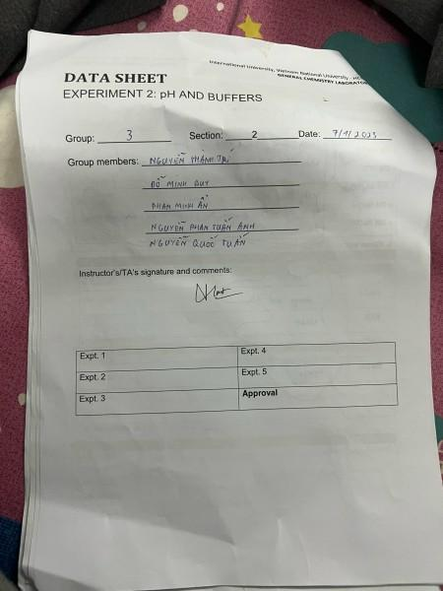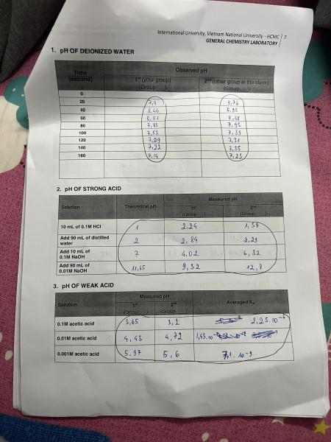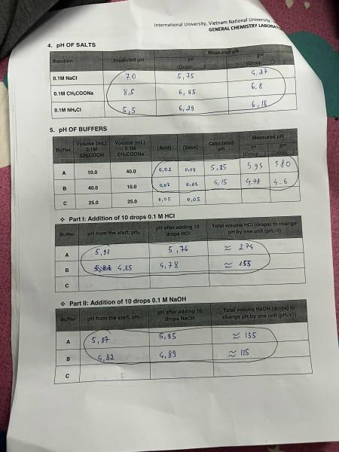

END.